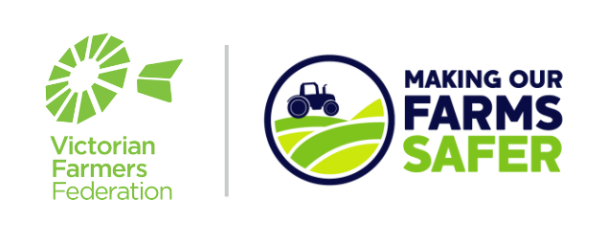
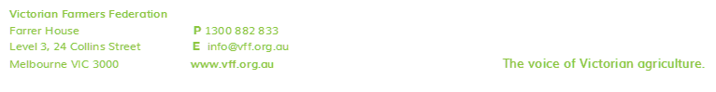
Templates for Farmers:
Training Competencies

From Page 2 onwards, this document provides a template to enable you to create a training competency record, specific to each piece of equipment in your company. Following these instructions will mean that your company is one step closer to becoming compliant with your OH&S responsibilities.
It is important to note that simply having this record is not enough to discharge your employer duties.

Instructions for Use:
- Save this word document, and double click the header to insert your company name and remove the highlight.
- Read through the listed skills and add/remove/change any options for the wording as required. Delete the highlighted reminder when you’re happy with the list.
- Fill in the table at the bottom with the version number, date, your name and a digital signature (or you can print the document off, sign it and scan it back in for your records).
- Print/Save a new copy of this file, to take your employees through the list of skills, and assign a Yes/No/NA answer.

What to do next:
- Use this training document to induct new employees, and also to provide training for existing employees.
- This is also worthwhile discussing during a toolbox meeting. A record of who is in attendance should be kept.
- Take on and address any feedback or concerns that your employees may have. Adjust as necessary.
- Once the training is completed, the Assessor and the Employees should all sign and date the form.
- Place a copy of this training record in every participating Employee’s employment file.

To protect our workers, our animals and our equipment, we need to ensure that if you do a task that you are competent to do it, or you are under the supervision of someone who is competent and can train you. Once you have been assessed as competent we expect you to follow the training provided at all times. If you are asked to do a task for which you are not competent then let the person who has requested it know, so that supervision or training can be arranged.
Cattle Handling
Skills and Competency Required | Yes/No/NA
Demonstrates use and has understanding of flight zone and flight distance
Positions self-outside of the kick zone
Properly positions self at gates
Indicates, demonstrates or can verbalize an awareness of escape routes prior to entering pen
Reads cattle moods, stress levels & disposition and adjusts approach as required
Communicates position to other workers
Is aware of and follows work alone rules
Checks facilities to ensure ease of flow, working chutes squeezes and gates
Utilizes appropriate PPE
Approaches sick or downed animal from the spine side with caution
Does not reach through bars of “head lockers” when removing collars
Demonstrates awareness and is conscious of distractions in the handling area
Is calm, patient and deliberate around the cattle, aware of noise as a stressor
Is aware that if in doubt the worker is to get out
Checks behind self when movement through cattle is required
Knows not to get between a cow and their calf
Knows how to move bulls and when to stay well clear of them
Wears appropriate PPE
Demonstrates safe storage, use and disposal of vet chemicals and sharps
AMEND OR ADD AS NECESSARY

The following person(s) have been assessed as competent on (date) …………………………………….
Assessed by (print name and signature) ………………………………………………………………..
Employee Name | Employee Signature

NOTE:
Don’t forget to retain a copy of this competency training document on each individual’s employment file.

Version Number | Date Approved | Document Author | Author Signature
1.0

